Sum of Diffusion

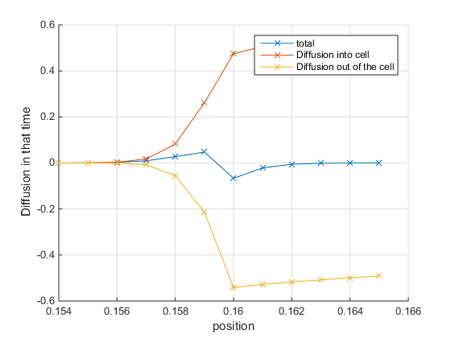

For some position look at the first global wave; Calculate the area under the diffusion graph and plot them in terms of the positive and negative component